Cyber Resilience in Firms, Organizations, and Societies

Ghaida Bandar Aldossry
Dept. of Computer Science
University of Hafar Al-Batin
Hafar Al-Batin, Saudi Arabia
s2231004728@uhb.edu.sa

Abstract
Cyber resilience involves most societal actors, i.e., organizations, individuals, threat actors, governments, insurers, etc., at most levels of organization. Actors are embedded within each other and choose strategies based on beliefs and preferences which impact and are impacted by cyber resilience. The article reviews the literature, attempting to capture the core ingredients of cyber resilience. Non-threat actors seeking to obtain cyber resilience are distinguished from threat actors. Actors have resources, competence, technology, and tools. They make choices that impact cyber resilience for all actors, including themselves. Cyber resilience relates to cyber insurance through entry requirements or preconditions for cyber contracts, need for various services such as incident response, data gathering, and cover limitations. Cyber resilience is linked to the Internet of Things, which in the future can be expected to simplify life through artificial intelligence and machine learning, while being vulnerable through a large attack surface, insufficient technology, challenging handling of data, possible high trust in computers and software, and ethics.

Keywords
Cyber resilience, recovery, non-threat actors, threat actors, levels of organization, insurance, Internet of Things.

I. Introduction
Resilience has been analyzed extensively within risk analysis, especially related to physical infrastructures. Knowledge within mature research fields gets more settled into practices, laws, and regulations, the education of practitioners, etc. Cyber resilience currently experiences many developments. Our knowledge about the factors associated with cyber resilience grows but needs to adapt to rapid changes. Enhancing our understanding of cyber resilience becomes imperative. A mapping of relevant factors is essential.
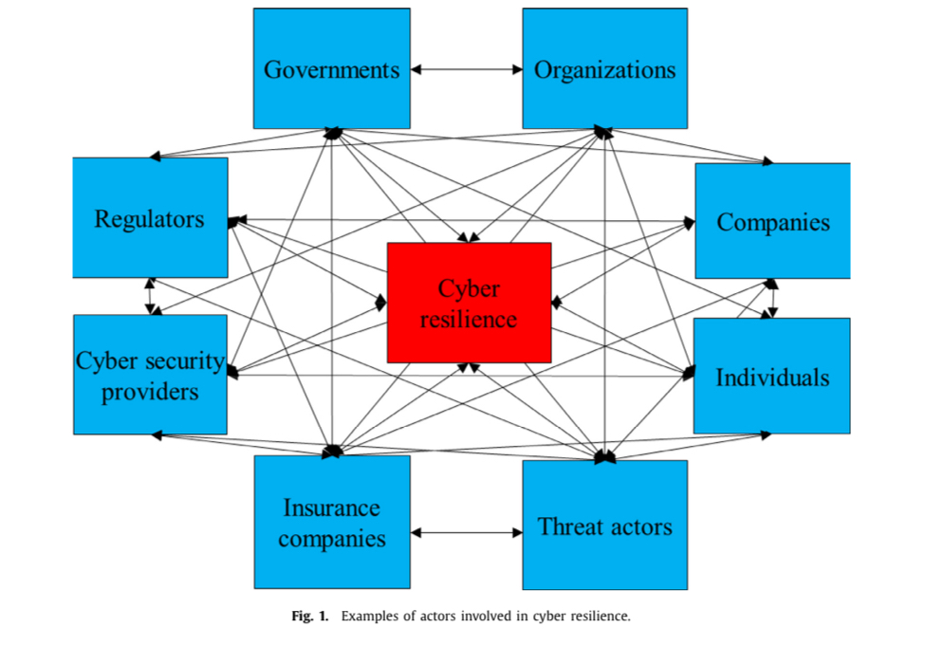

II. Contribution
The article reviews the state of the art of some of the enormous literature within cyber resilience and intends to identify the core ingredients of cyber resilience to facilitate progress beyond the state of the art. Common definitions of cyber resilience are presented and further refined and clarified. Non-threat actors are distinguished from threat actors and hybrid actors. Actors which may be threatening or not, levels, beliefs, and preferences relevant for cyber resilience are presented. Resources, competence, technology, tools, and strategies in cyber resilience are outlined. The relationship between cyber resilience and cyber insurance is sketched. The role of cyber resilience in the future is assessed. Future research possibilities are suggested.

III. Literature Review
The literature on cyber resilience is categorized into history and review, infrastructure, management, policy, economics, insurance, and the Internet of Things (IoT). Historical perspectives, definitions, and resilience models are discussed, along with key contributions from researchers emphasizing agile responses and adaptation.

IV. Defining Cyber Resilience
Cyber resilience is defined as the ability of an actor to resist, respond, and recover from cyber incidents to ensure operational continuity. This resilience impacts the systems and information that an actor requires for operations. Actors are categorized as non-threat, threat, or hybrid, each with distinct intentions and approaches toward resilience and vulnerability management.

V. Factors Influencing Cyber Resilience
The elements essential to cyber resilience include resources, competence, technology, tools, and strategic decision-making. Effective use of resources and technological advances enable actors to establish strategies that support resilience. These strategies must adapt to dynamic threat landscapes, emphasizing both protection and recovery.
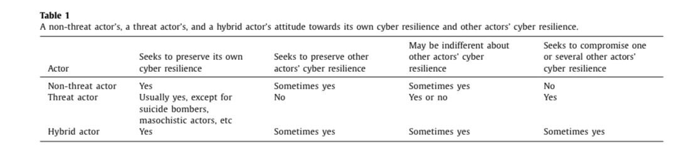

VI. Cyber Resilience and Cyber Insurance
Cyber resilience and cyber insurance are intertwined as risk transfer mechanisms. Cyber insurance enhances resilience by imposing security standards and providing support services, such as incident response. Insurers collaborate with policyholders to promote best practices, incentivizing organizations to meet resilience criteria through reduced premiums or coverage options.

VII. Future Challenges
The IoT introduces new resilience challenges due to increased connectivity and interdependencies. IoT devices create a vast attack surface that complicates data security and trust management. Ethical concerns, over-reliance on automation, and regulatory demands will drive future resilience frameworks, emphasizing collaborative, multi-stakeholder approaches.

VIII. Conclusion
Cyber resilience is crucial for maintaining continuity in a connected world. This paper outlines the roles of various actors, the impact of cyber insurance, and the growing complexities associated with IoT. Future research should explore adaptive, cross-functional resilience strategies and enhanced metrics to evaluate resilience effectiveness across sectors.

References
Alabdan, R. "Phishing attacks survey: Types, vectors, and technical approaches," *Future Internet*, vol. 12, no. 10, p. 168, 2020.

